AWS Task 4
Launch an EC2 instance (Linux and Windows) along with a web server. Then, create an EBS volume of 5 GB, attach it to an EC2 machine (Linux and Windows), and take a snapshot. Finally, create an EBS volume using the taken snapshot.

Created EC2 Instance:
Linux & Windows:

Volume Mounted Linux and Windows:

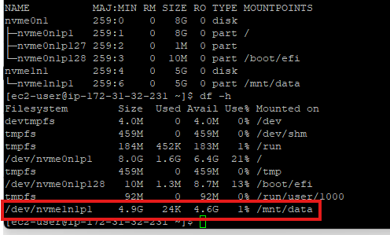
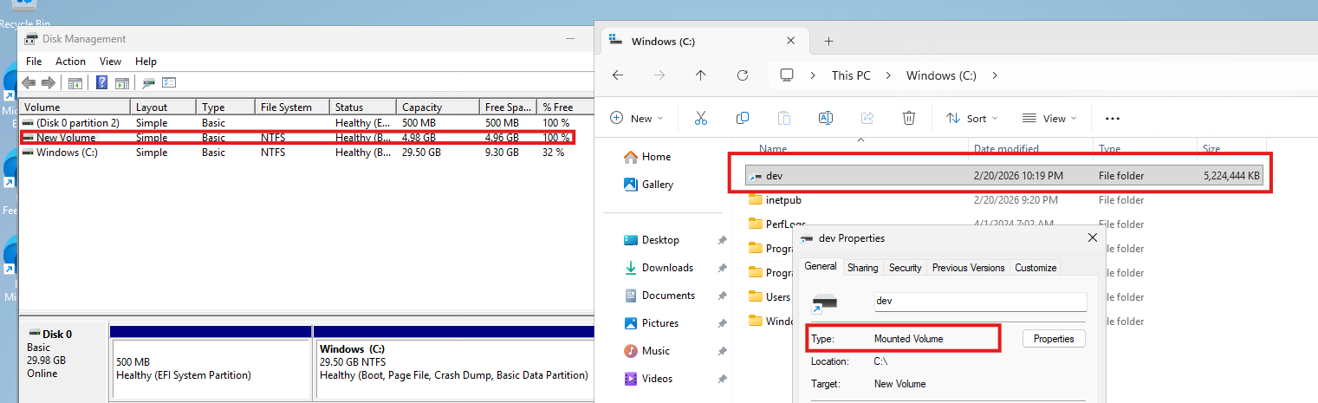

Snapshot taken for the Volumes:
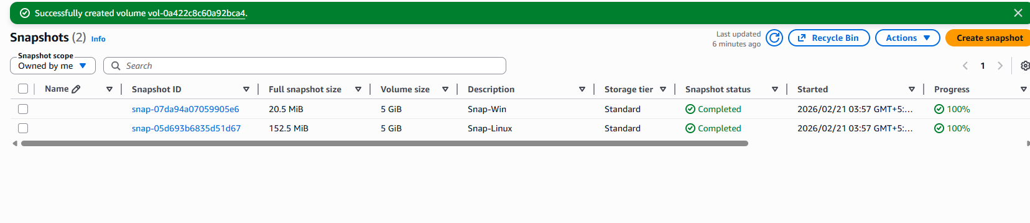

EBS volume recreated using the taken snapshot.

